4.53: Differentiating twice, the acceleration of the helicopter as a function of time is
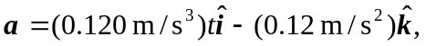
and at 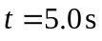, the acceleration is
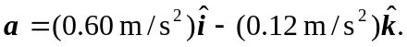
The force is then

